University Of Engineering and Technology, Lahore Computer Engineering Department

Course Name: | Course Code: CMPE-112L
Assignment Type: | Dated: 2march2026
Semester: | Session:
Lab/Project/Assignment #: 2 | CLOs to be covered: CLO1
Lab Title: for loop | Teacher Name: Hafiz Muhammad Mubashar

Lab Evaluation:

CLO1 | Apply appropriate programming techniques to create executable programs to solve well defined problems
 | Level1 | Level2 | Level3 | Level4 | Level5 | Level6
(5)
Total |  |  |  |  |  | /5

Rubrics for Current Lab Evaluation

Scale | Marks | Level | Rubric
Excellent | 5 | L1 | Submitted all lab tasks, BONUS task, have good understanding.
Very Good | 4 | L2 | Submitted the lab tasks but have good understanding
Good | 3 | L3 | Submitted the lab tasks but have weak understanding.
Basic | 2 | L4 | Submitted the lab tasks but have no understanding.
Barely Acceptable | 1 | L5 | Submitted only one lab task.
Not Acceptable | 0 | L6 | Did not attempt

LAB No 2
Lab Goals/Objectives:
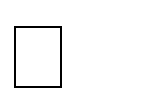


Understand the concept of loops in Python. Learn how to use a for loop for repetition. Perform repeated tasks efficiently.

Understand iteration through sequences.

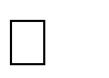


Equipment Required: Computer/Laptop Python IDE
Python Interpreter

Theory:
A for loop is used to repeat a block of code a specific number of times or to go through each item in a list, string, etc.Think of it like: "do this task for every item"

Lab Work:

Task 1
Write a python code to convert a binary number entered by the user into its equivalent decimal number.
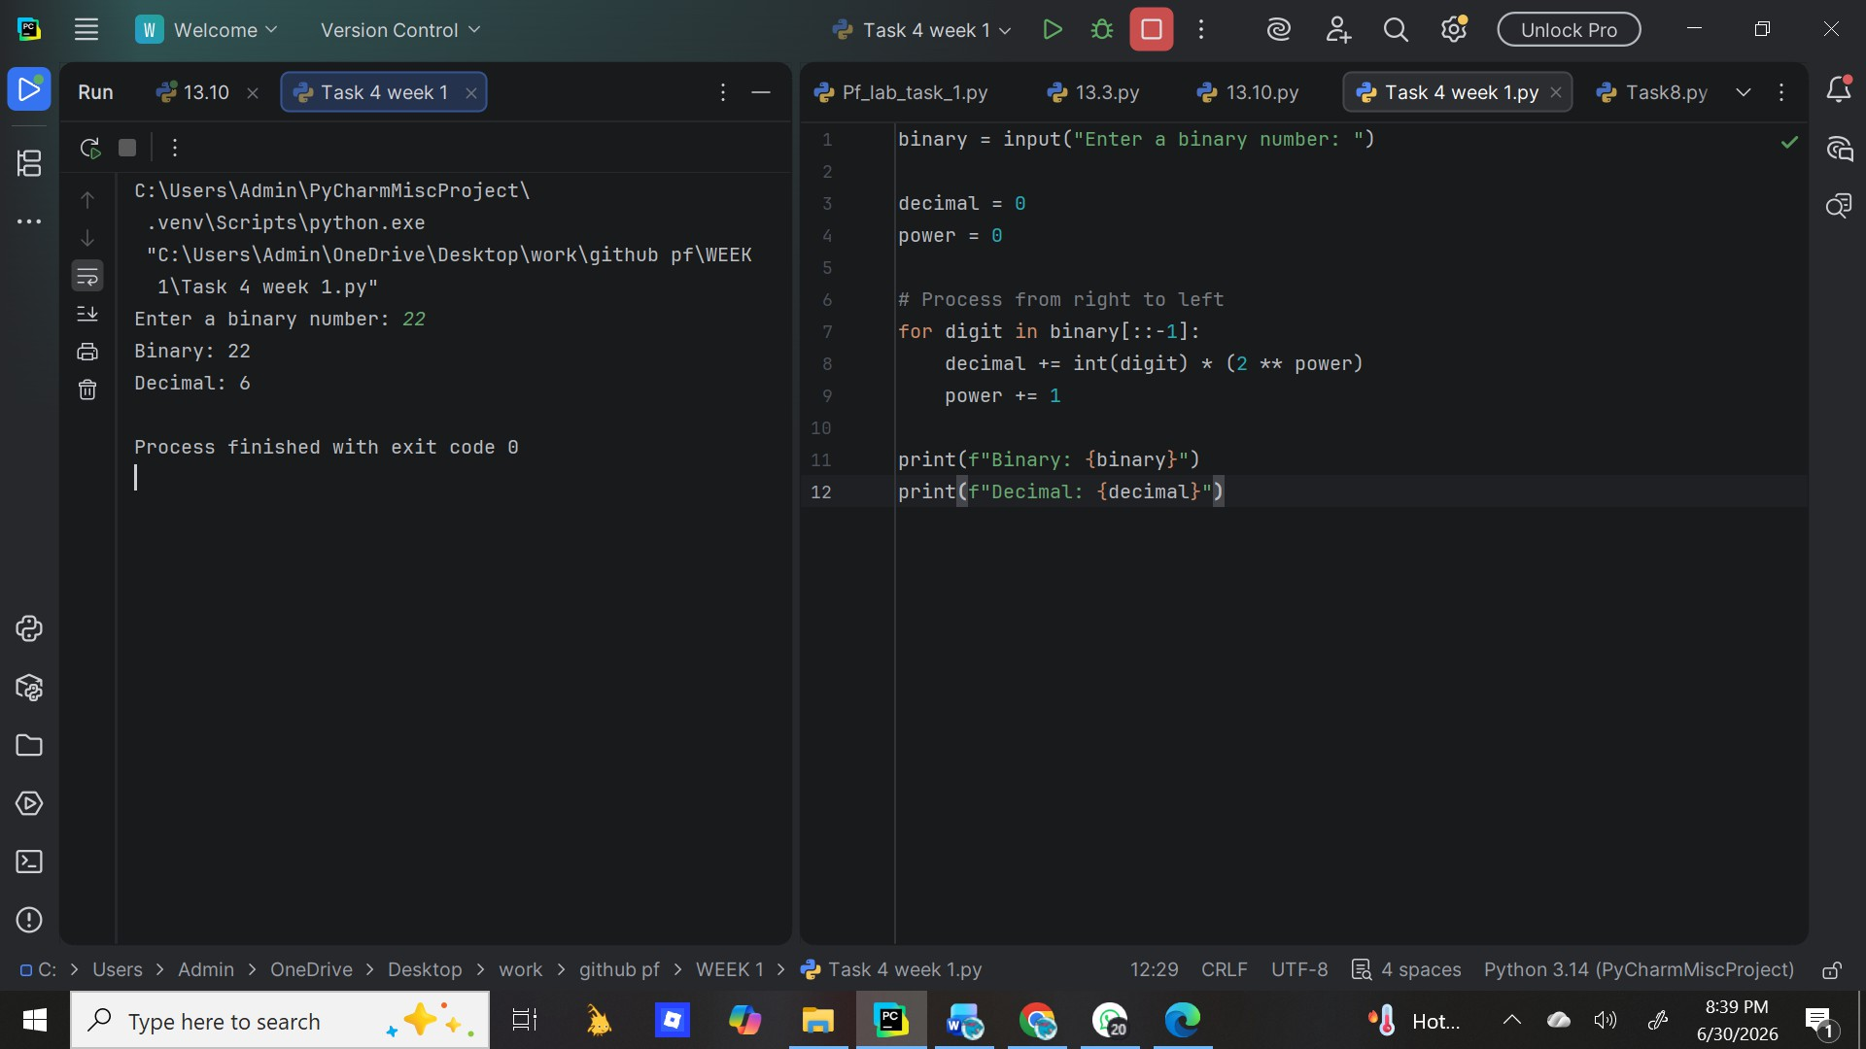

Task 2
Write a python program that counts the number of vowels and consonants in a sentence entered by students.

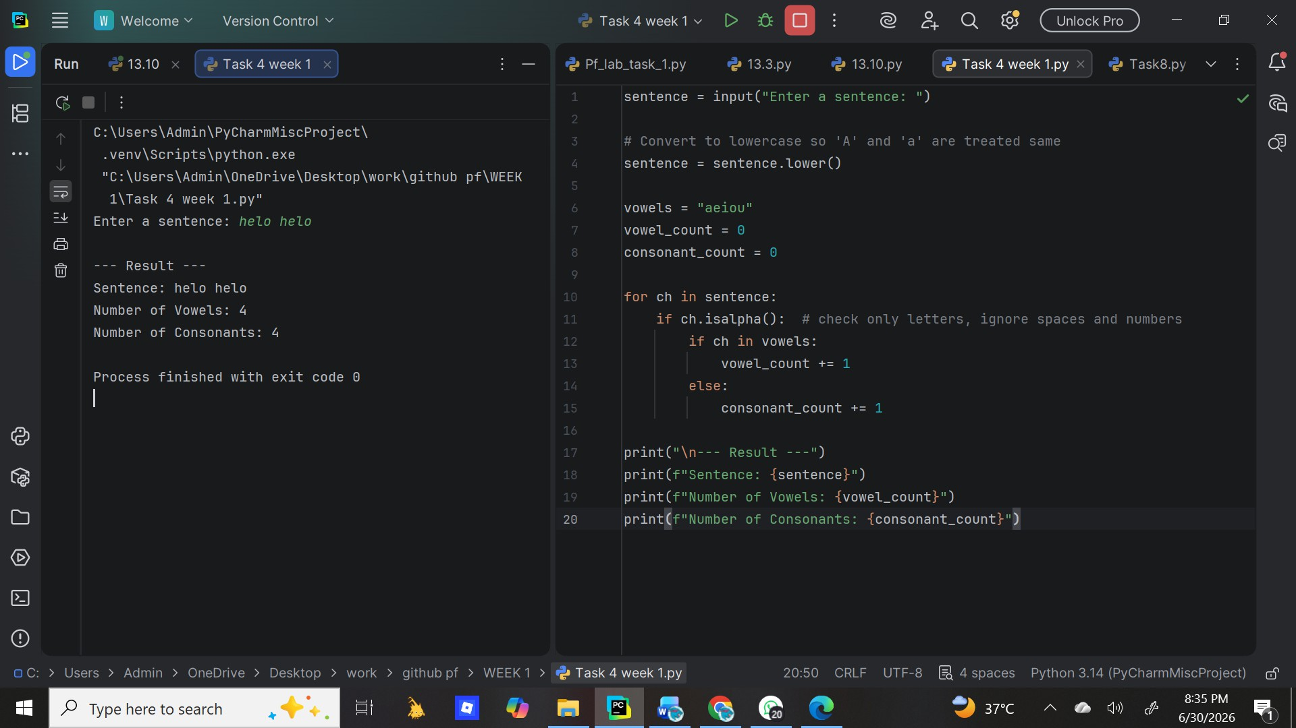

Task 3
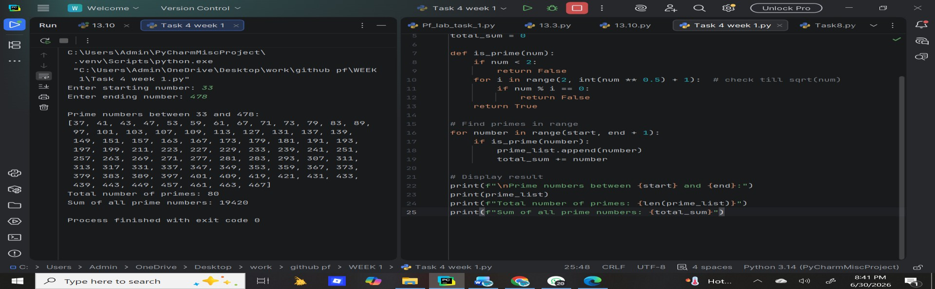
Write a python program that finds all prime numbers between a given starting and ending number and also calculate their sum.

Task 4
Write a python program to generate a random password based on user preferences.

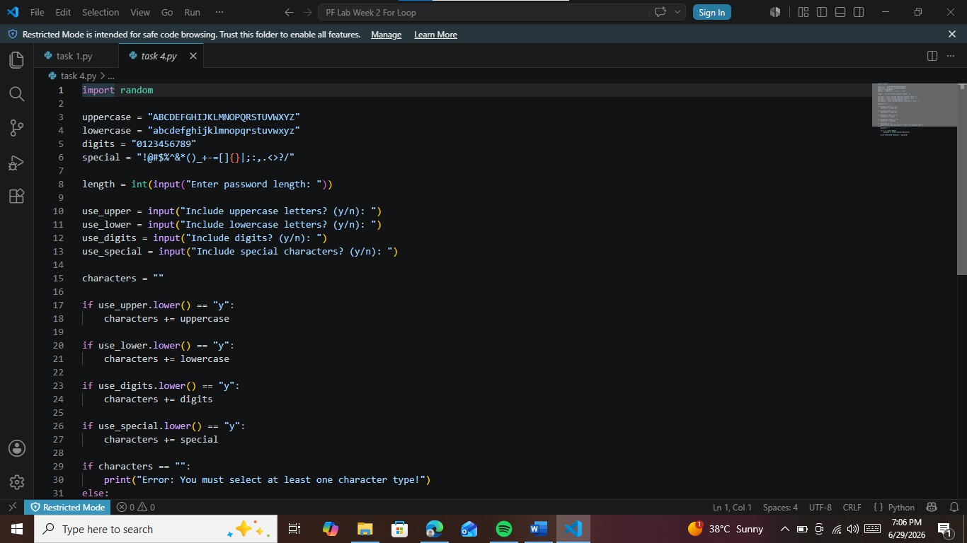

Task 5
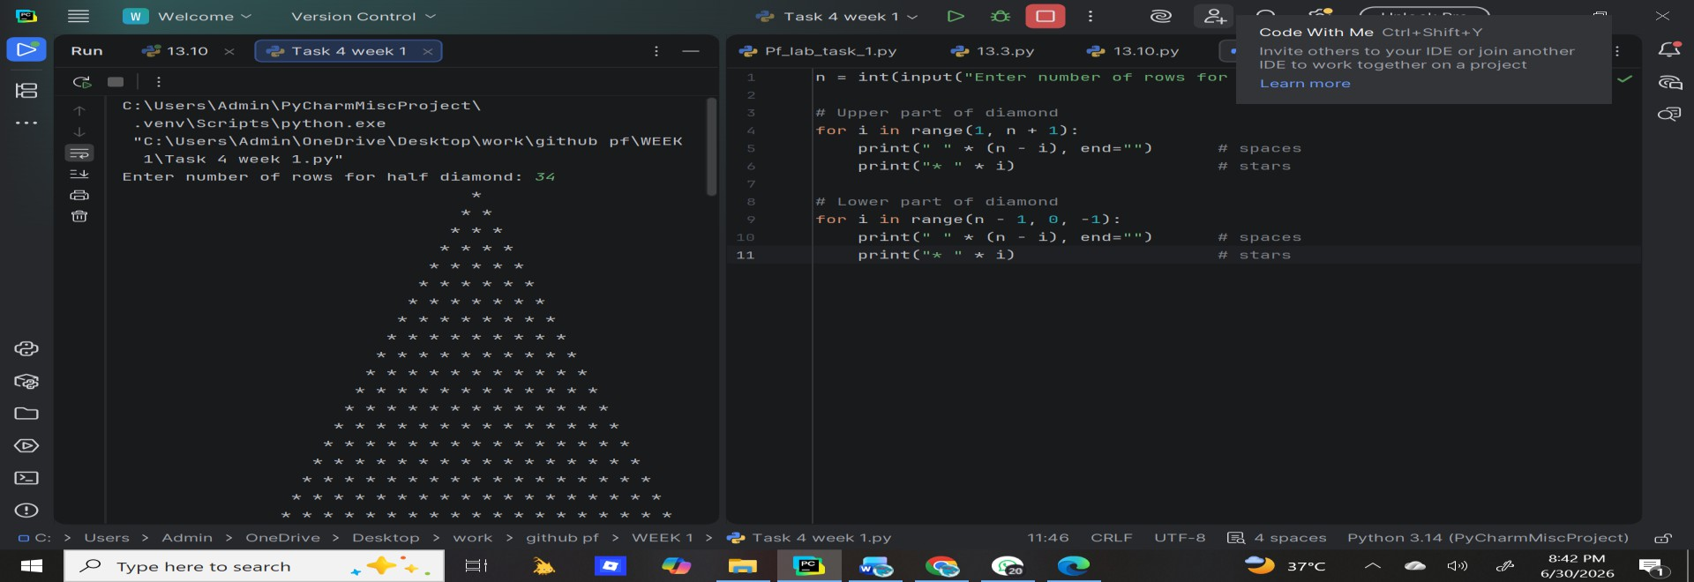
Write a python program to print a diamond shaped pattern using asterisks.

Task 6
Write a python program to calculate the percentage and grade for multiple students.

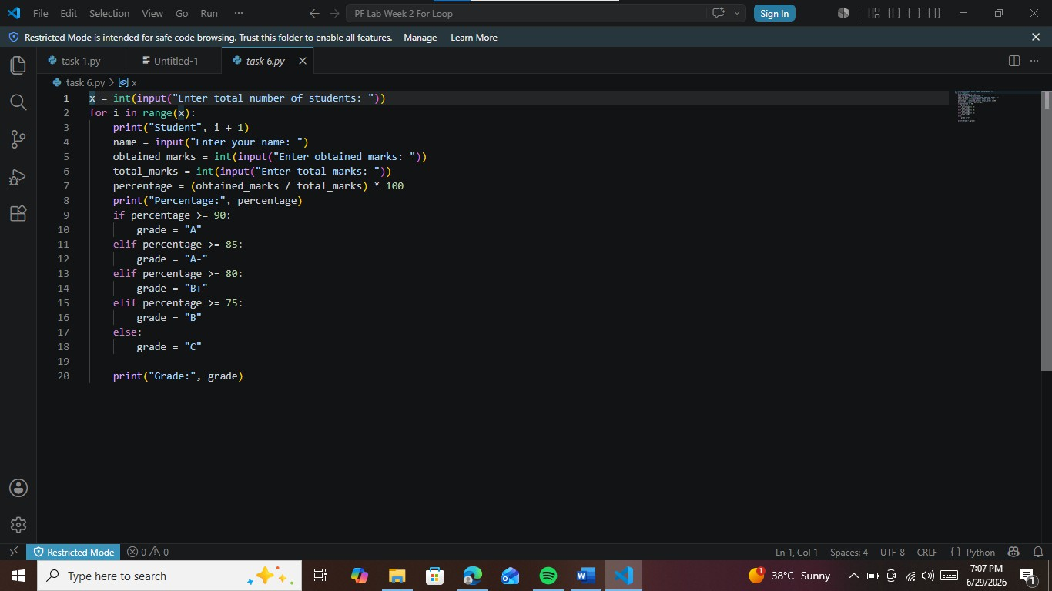

Conclusions:
The for loop is one of the most used loops in Python. Key Points:Purpose: It is used to repeat a block of code a specific number of times, or to go through each item in a sequence like list, string, or range.When to use: Use for loop when you know in advance how many times you want to repeat, or when you want to process every element one by one.Advantage: It makes code shorter, cleaner, and easier to read compared to writing the same code again and again.

